Lab Exercise 4- Signed Commits in Git and GitHub
Objective:
To configure Git to sign commits with GPG, push them to GitHub, and verify commit authenticity for secure code contribution.

Prerequisites:
- Git installed on your system
- GPG (GNU Privacy Guard) installed and configured
- GitHub account with a repository (you own or have write access to)
- Basic knowledge of Git commands

Step 1 – Generate or Use an Existing GPG Key
- Check for existing keys
gpg --list-secret-keys --keyid-format=long
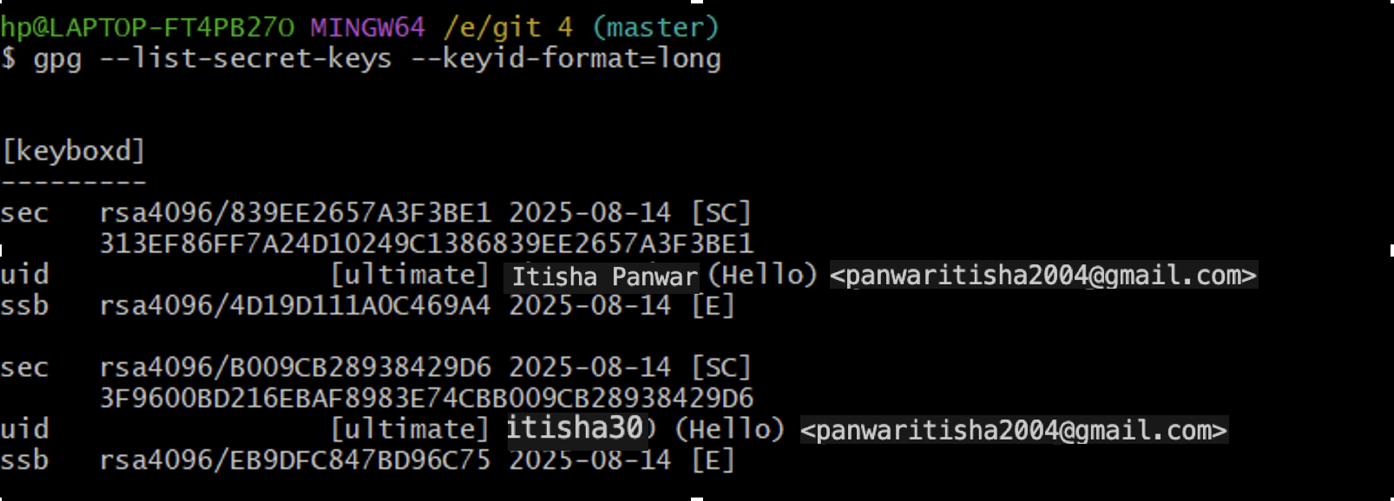

- If no key exists, generate a new one
gpg --full-generate-key
$ 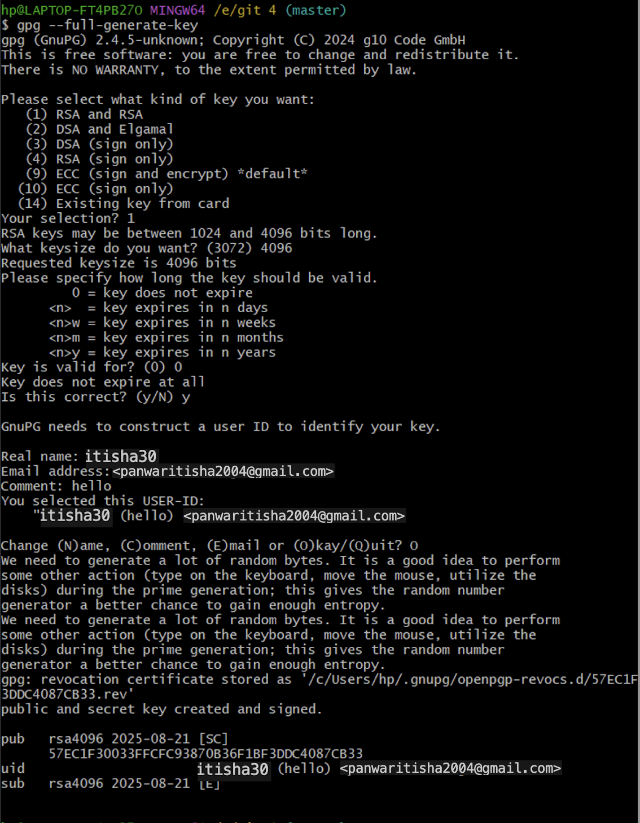
  - Select RSA and RSA
  - Key size: 4096
  - Expiration: 0 (never) or a fixed date
  - Enter your GitHub-registered name and email
- Get your key ID
gpg --list-secret-keys --keyid-format=long
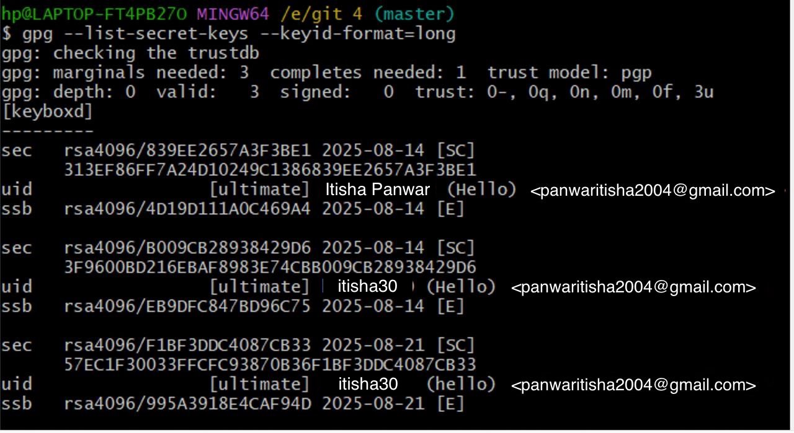
Example output:
sec rsa4096/3AA5C34371567BD2 2025-08-13 [SC]
Here, 3AA5C34371567BD2 is your key ID.

Step 2 – Add GPG Key to GitHub
- Export your public key:
gpg --armor --export YOUR_KEY_ID
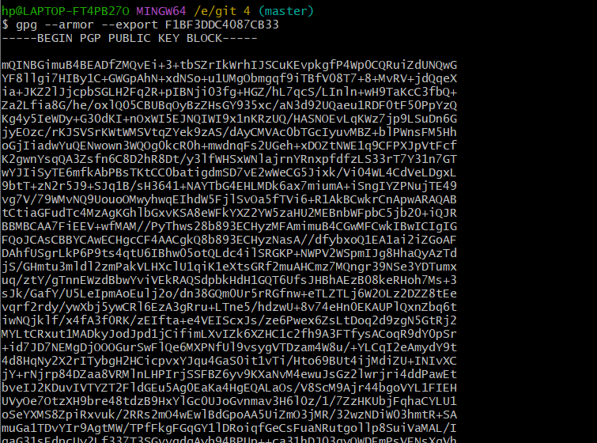
- Copy the output.
- Go to GitHub → Settings → SSH and GPG Keys → New GPG Key.
- Paste your key and save.

Step 3 – Configure Git for Signed Commits
- Tell Git which key to use:
git config --global user.signingkey YOUR_KEY_ID
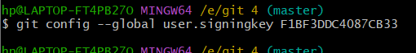
- Enable signing for all commits:
git config --global commit.gpgsign true
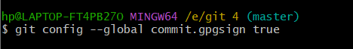

Step 4 – Make a Signed Commit
- Clone your repo (or use an existing one):
git clone https://github.com/<username>/<repository>.git
cd <repository>
- Edit or create a file:
echo "Secure commit test" >> secure.txt
git add secure.txt
- Commit with signing:
git comm4it -S -m "Add secure commit test file"
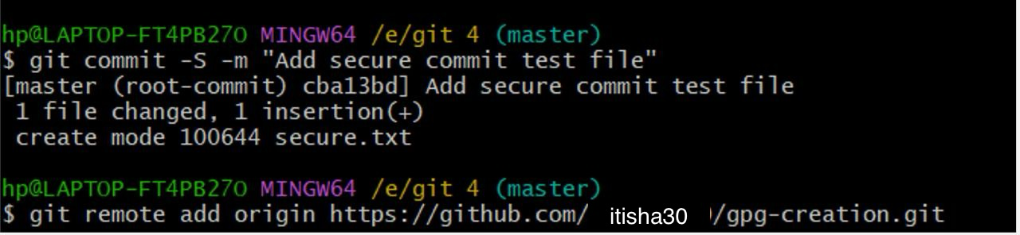
- Enter your GPG passphrase when prompted.

Step 5 – Push and Verify on GitHub
- Push the commit:44
git push origin main
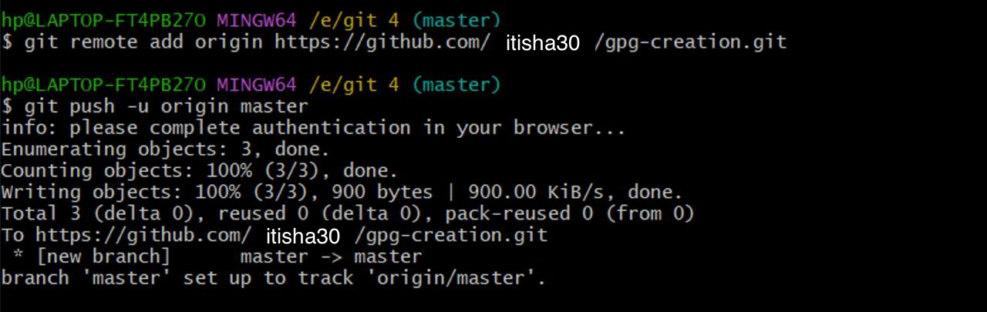
- Go to your repository on GitHub → Click the commit → You should see a green “Verified” badge.
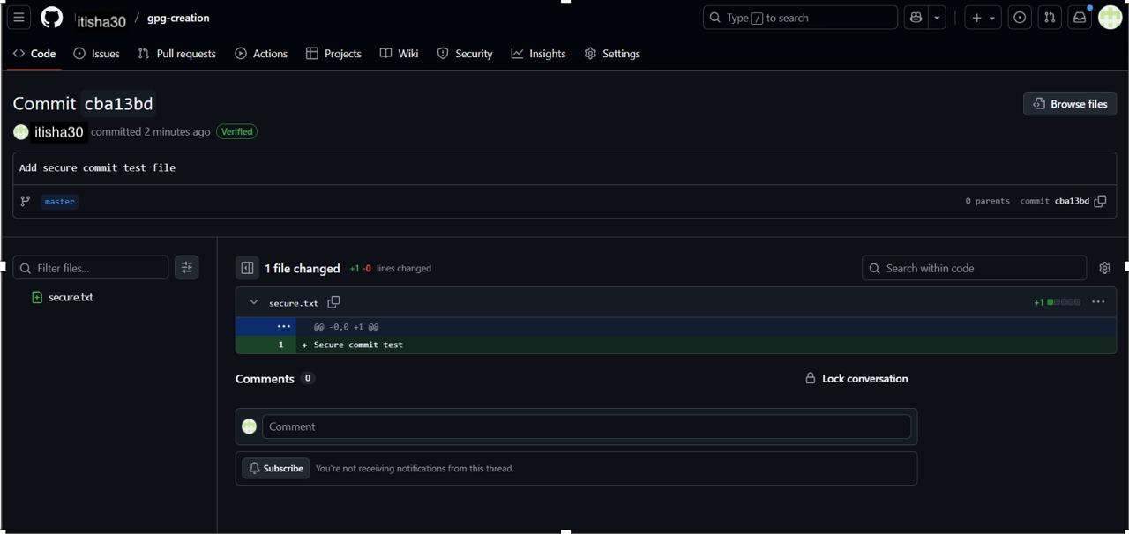

Step 6 – Local Verification of Commit
git log --show-signature
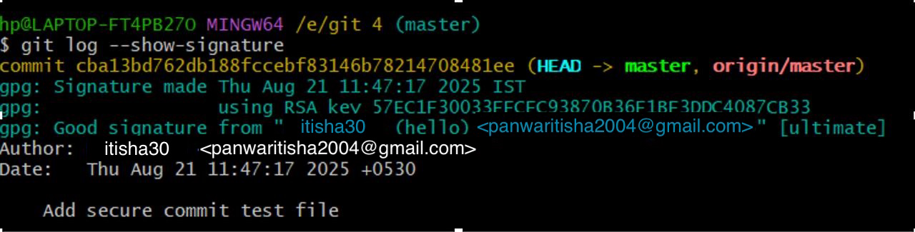
This will display the GPG verification details locally.

Use Case
Signed commits prevent identity spoofing in collaborative projects, ensuring only verified authors can make trusted changes in critical codebases.

